1. **Create a repo on GitHub**

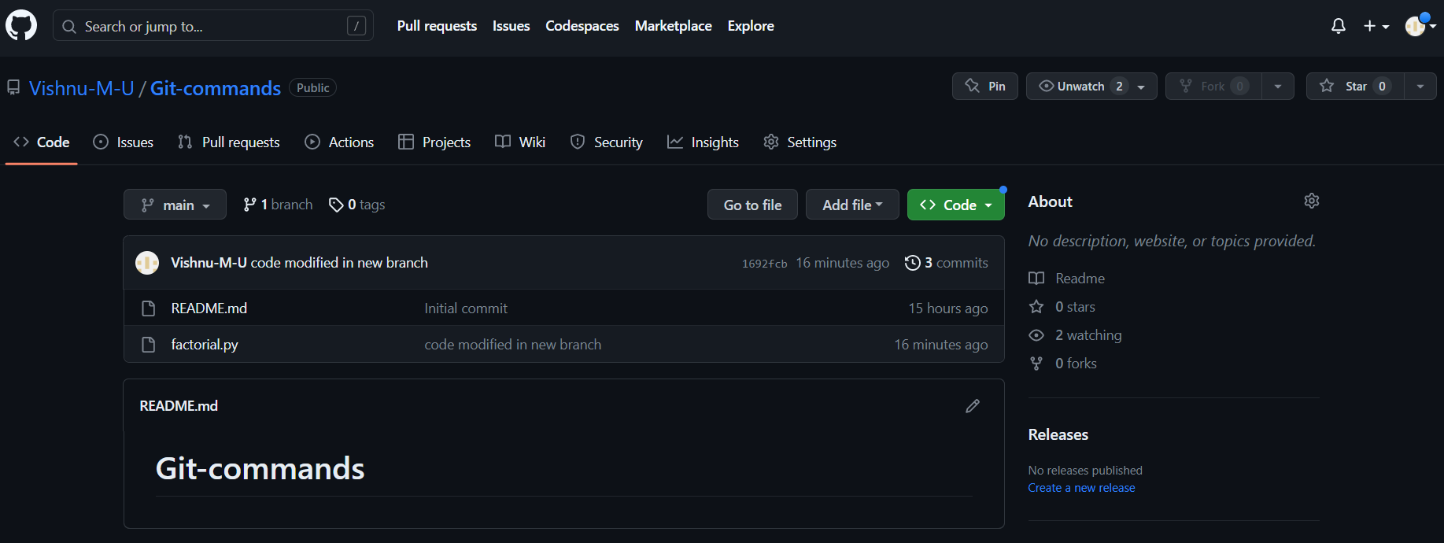

1. **Clone it into your local system**

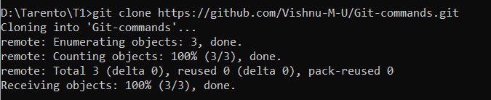

1. **Add a file in that directory**

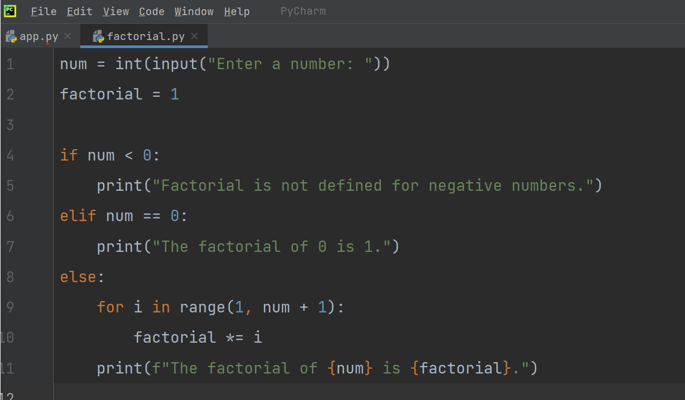

1. **Add, Commit and Push it to the remote repo**

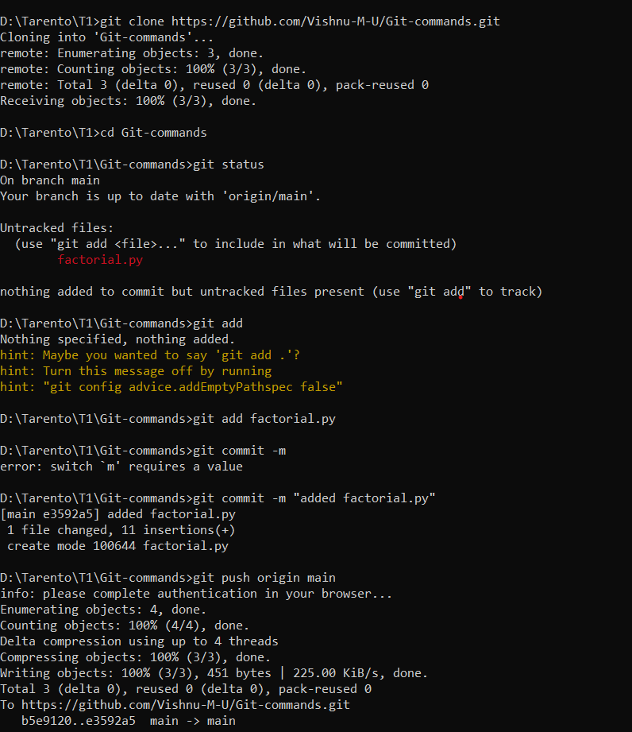

1. **Execute these commands - git status, git diff and git log**

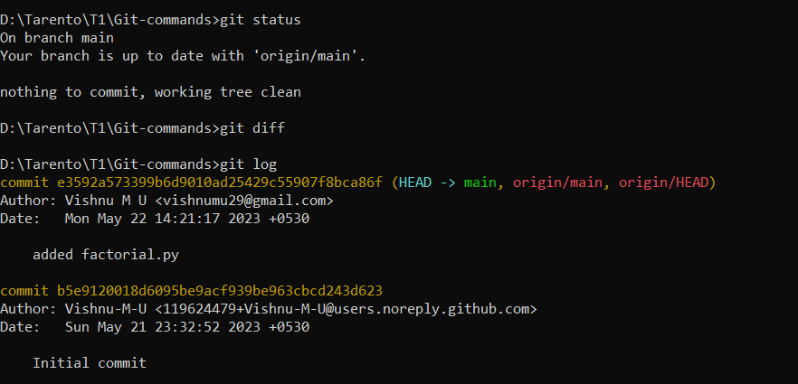

1. **Create a branch**

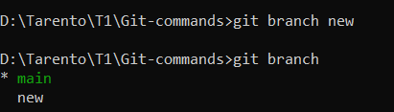

1. **Checkout to that branch and make some code modifications**

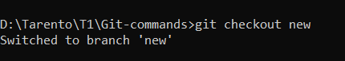

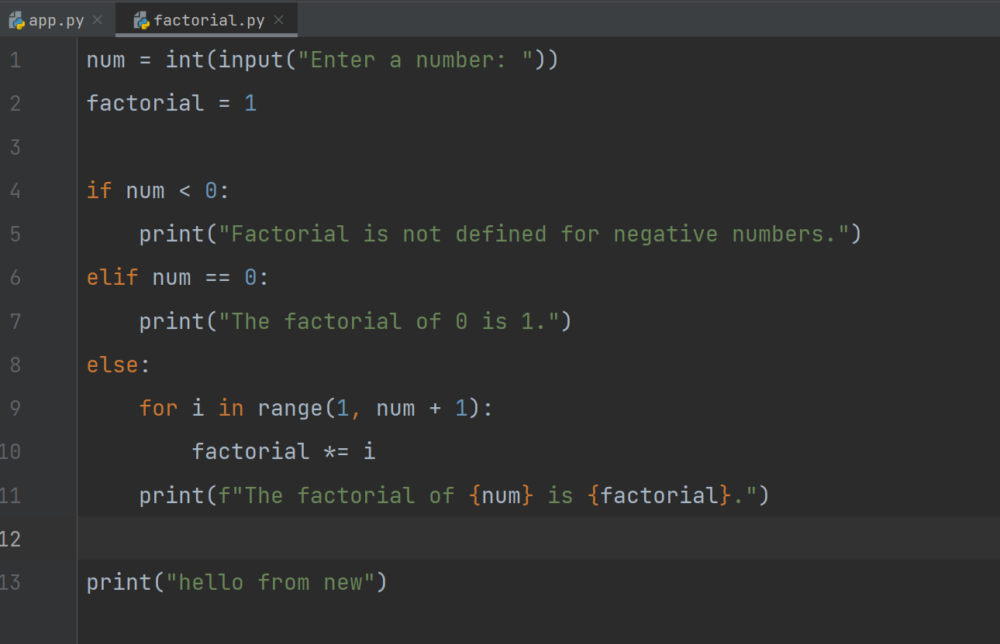

1. **Then add and commit the changes while you are in the new branch**

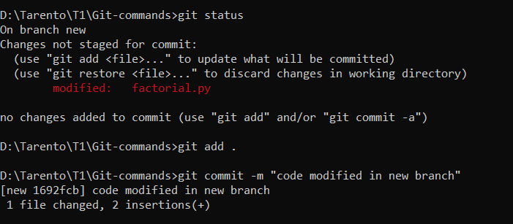

1. **Checkout to the master branch and merge both the branches**

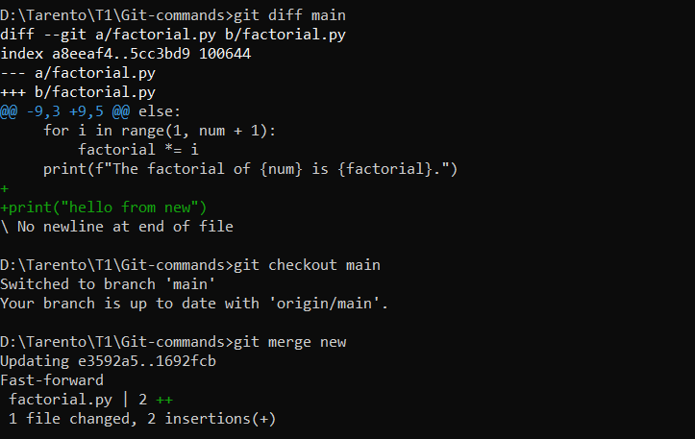

1. **Add, commit and push the changes to remote repo**

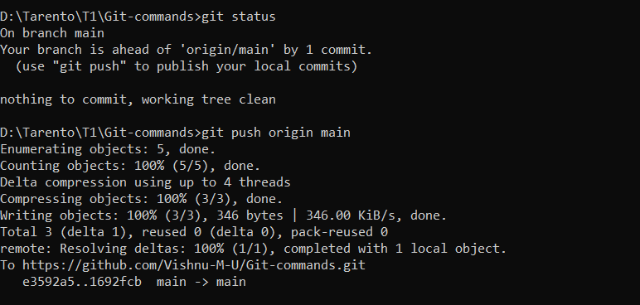

1. **Create another branch and delete it**

